Text:
ARTICLE VII - HOURS OF WORK AND OVERTIME

Section 1:

- The regular hours of work shall be eight (8) hours per day and forty (40) hours per week, Monday to Friday inclusive.

Guidelines:
ARTICLE VII - HOURS OF WORK AND OVERTIME

Section 1, a):

This sub-section establishes the regular hours of work applicable to the regular production employee. This section does not guarantee any employee eight (8) hours per day or forty (40) hours per week. Regular Maintenance hours of work can deviate from this slightly (See Section 2).

Part 3 of the Employment Standards Act specifically states that if a collective agreement contains provisions regarding hours of work and overtime, and if the entirety of the provisions, considered together, meet or exceed the requirements, when considered together, of Part 4 (Hours of Work and Overtime) of the Act then the provisions of the collective agreement replace the requirements of Part 4 of the Act. It is the opinion of CONIFER that Article VII, Hours of Work and Overtime, replace the requirements of Part 4 of the Act. Any complaint or assertion from an employee or the Union that an employer is not complying with Part 4 of the Act should be reviewed with CONIFER and/or legal counsel.

During 1981 negotiations the industry negotiating (CONIFER) committee made a commitment that they would apply the 24 hours notice of shift change to employees (a feature of the Act at that time). Less than 24 hours notice of shift assignment change would result in OT (rate and one-half) for the first shift of the new shift assignment. This has translated into practice for CONIFER member companies.

The work “week” is defined through interpretation of the collective agreement to be Monday through Sunday.

Time Spent in Training Beyond Regular Hours:

The issue routinely arises as to whether time spent in “training” is considered part of the regular hours of work for the purposes of overtime eligibility. It is the consensus opinion of the CONIFER Negotiating Committee (at the January 2001 CONIFER Administration Manual update) that such time is included in the regular hours of work if attendance is because of direction from the employer. For example, a Kiln-Forklift Operator who works Monday to Friday is asked to come into work on Saturday to attend a Kiln Operation training course. This time is actually in addition to the 40 hours already worked and is therefore payable at rate and one-half.

This principle does not apply when employees must attend to the mill to complete selection or aptitude tests, such as the apprenticeship selection test.

Also, Article V, Section 3 (e) specifies that Lumber Graders who are required to take upgrade training shall receive regular straight time rates while engaged in such training.

It should also be noted that Article XII, Section 3, Safety and Health; provides for a maximum of two hours per week outside of regular working hours at straight time rates for time spent attending safety meetings.

Text:
ARTICLE VII - HOURS OF WORK AND OVERTIME

Section 1:
- Overtime will be paid at rate and one-half for all hours worked in excess of eight (8) in a day, and for Saturday and/or Sunday, with the following exceptions:

Double straight time rates shall be paid for the following:

- Hours worked in excess of eleven (11) hours per day.
- Hours worked on Sunday by employees who have worked five (5) shifts during the preceding six (6) days.
- Item ii) above shall not apply to employees who work on Sunday as a regular scheduled day.
- For purposes of this provision, a Statutory Holiday shall be considered as a shift worked.

Guidelines:
ARTICLE VII - HOURS OF WORK AND OVERTIME

Section 1, b):

This section should be read carefully and applied to specific scenarios in the workplace. It is not the intent of these guidelines to simply re-iterate the language in the collective agreement; however, some guiding statements may be of assistance:

- Rate And One-Half Is Payable In The Following Cases:
- Hours in excess of 8 per day up to 11 hours
- Hours in excess of 40 per week (this calculation excludes hours worked in excess of 8 in any one day)
- The first 11 hours worked by production employees on Saturday doing production work
- Hours worked by production employees, doing production work, on Sundays except where double time is applicable (See Below)
- Casual employees work for straight time pay as outlined in Section 11 of this Article
- Hours worked on statutory holidays except where double time is applicable (See Below)

Double Straight Time Is Payable In The Following Cases:
- Hours in excess of 11 per day
- Hours worked on Sunday by employees who have worked five shifts during the preceding six days, except employees who work Sunday as a regularly scheduled day.
- For the determination of five shifts during the preceding six days, a statutory holiday is considered a shift worked.

SUNDAY EARLY STARTS CONTIGUOUS TO MONDAY GRAVEYARD:

The question routinely arises regarding what rate of pay is applicable when the arrangement is made whereby employees on a Monday graveyard shift commence work early, technically on Sunday night. The initial answer was provided in a 1982 CONIFER interpretation case decided by Interpreter Hope (Case Reference #1). Interpreter Hope concluded that when employees start at 10:00 p.m. on Sunday night leading into the Monday graveyard shift, the appropriate rate was time and one half for the hours on Sunday. They concluded this based on the consideration of the hours on Sunday to be “contiguous” to the Monday shift, and a circumstance whereby an employee is regularly expected to come to work at that time. This decision was reinforced in a subsequent arbitration case from Slocan Group, Plateau Mills, decided by Arbitrator Brokenshire in an award dated March 12, 2003. (See Case Reference #2)

The extent to which this jurisprudence should apply in the context of Sunday early starts was discussed at Right of Reference meetings in late 2005 and early 2006. CONIFER ultimately agreed with USW Locals 1-424 and 1-425 that any early start on Sunday contiguous to a Monday graveyard shift which resulted in more than two hours into the Sunday would trigger double time rates for the hours beyond two hours on the Sunday (the first two hours payable at time and one half), as long as other double time eligibility criteria are met. (i.e. five shifts worked in the preceding six days)

- Example:
  - Monday graveyard shift is 12:00 a.m. to 8:00 a.m.
  - Several employees commence work at 9:00 p.m. Sunday night to prepare the mill for the Monday graveyard shift.
  - Resulting rates of pay are:
    - One (1) hour at double time.
      - Contingent on five shifts worked in the preceding six days, otherwise time and one-half is applicable.
    - Two (2) hours at time and one half.
    - Eight (8) hours at straight time.

The resulting Letter of Understanding dated January 20, 2006 is attached for reference. The scope of the discussion relevant to this LOU was focused on rates of pay. The LOU should not be utilized to apply leverage in scheduling early start overtime on Sunday night contiguous to the Monday graveyard shift. Your historical practices for overtime scheduling purposes should be followed.

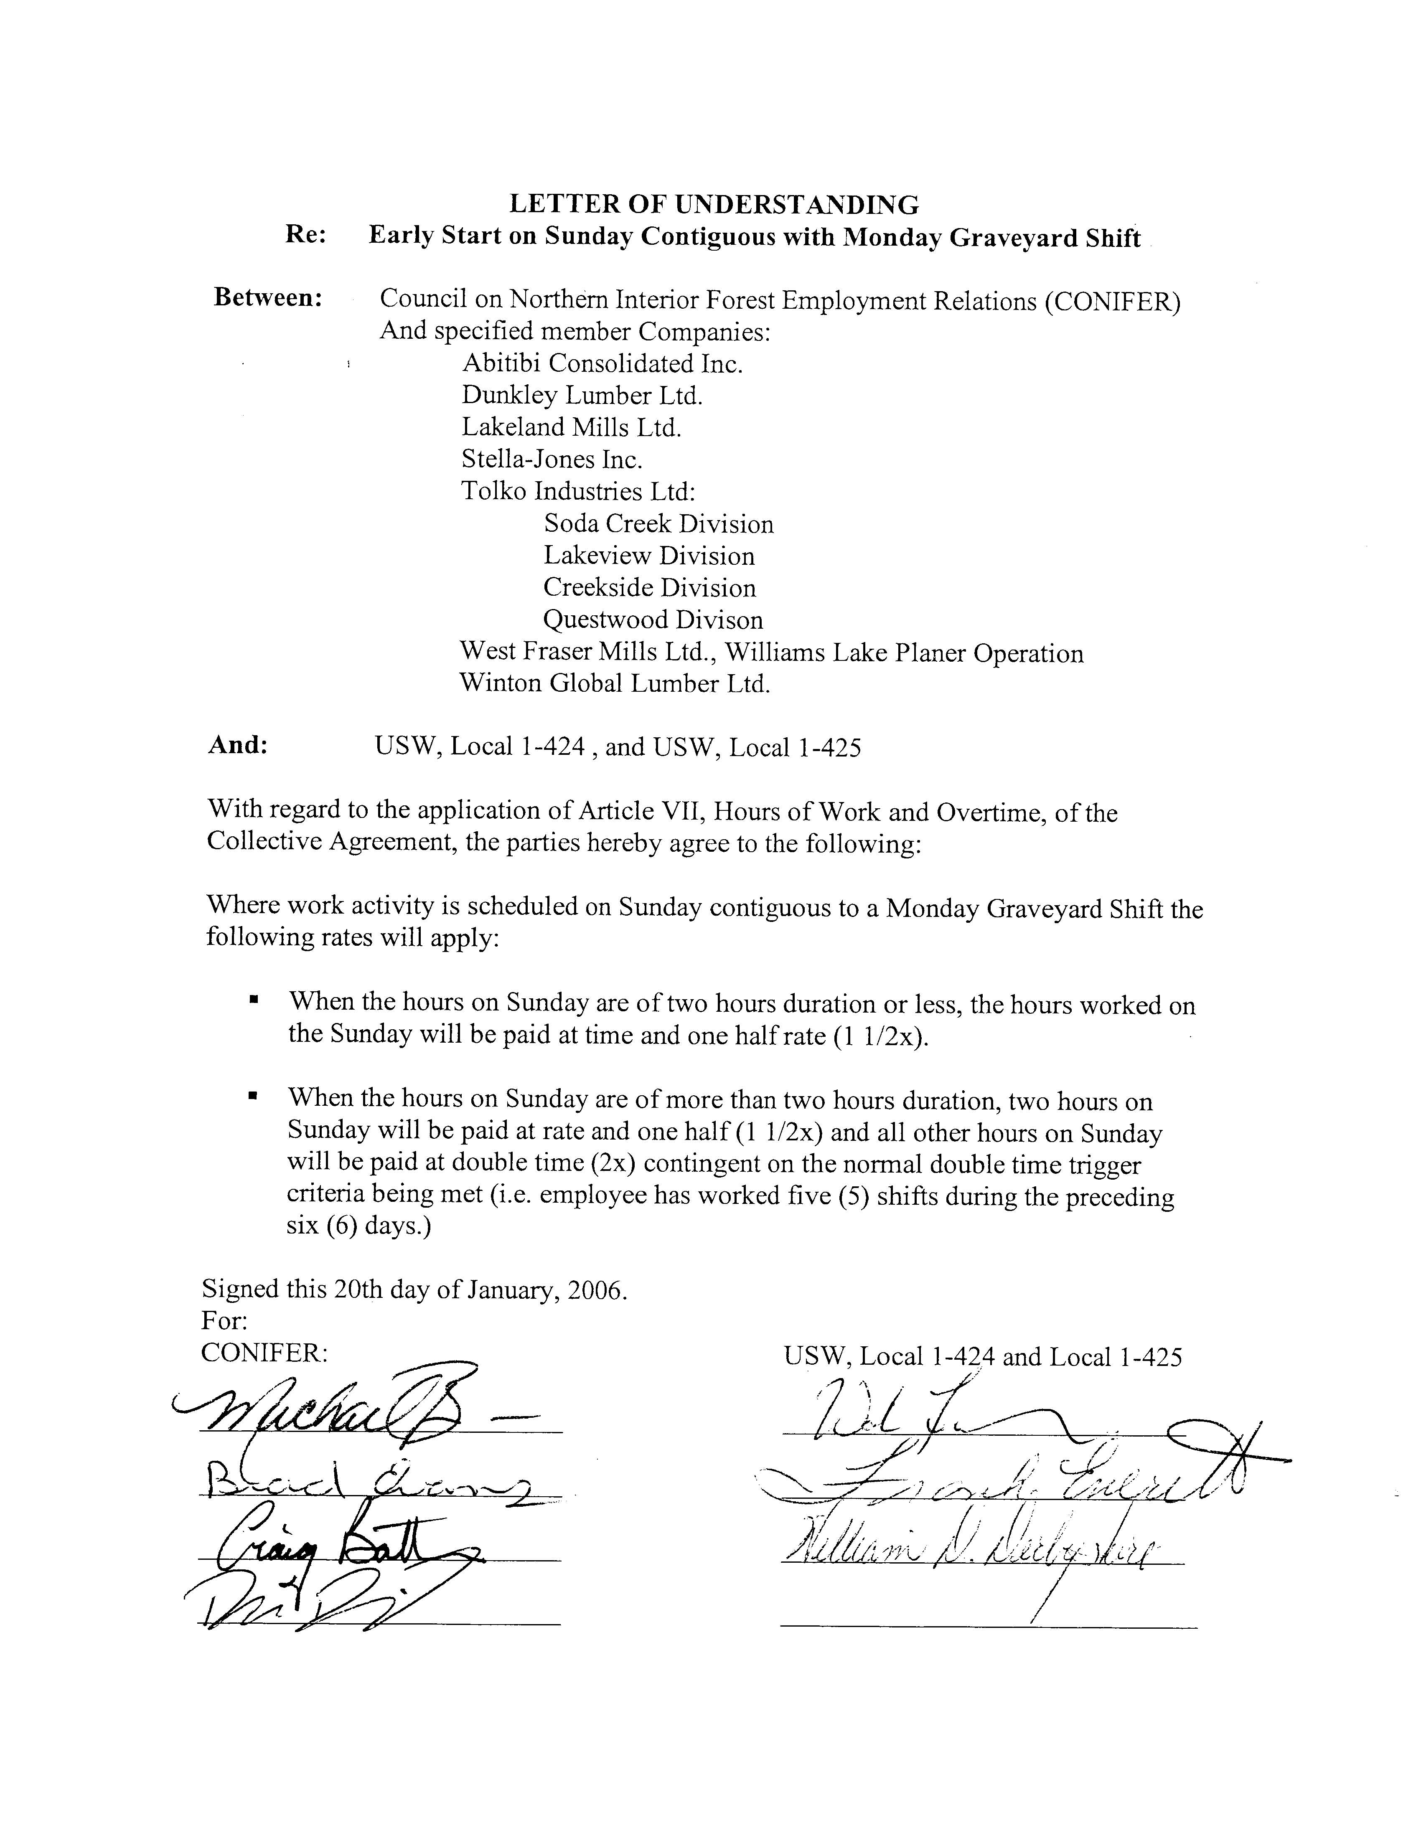
There are several points within Article VII, Hours of Work and Overtime, in which specific overtime rate entitlements are contingent on a specified number of hours worked “in a day” or “hours per day”. Specifically, Article VII, Section 1 b) and 1 b) (i), along with Section 2 b), and 2 b) (i) contain such statements. It is appropriate to elaborate on the definition of a day in order to properly administer these sections. A day, in this sense, is not necessarily midnight to midnight. If the language were applied to scenarios using a strict calendar definition of a day, it would lead to distortions from the intended application.

Example:
Employee commences work at 3:30 p.m. and works until midnight (12:00 am) (i.e.: normal afternoon shift)
- Result is 8 hours straight time pay
Employee remains due to shift extension of 2 hours until 2:00 am
- Result is 2 hours overtime

Under Article VII, Section 1 b) if one were to define a day as a calendar day (midnight to midnight) it could lead to improper application of this, and similar sections. Therefore, the meaning of “in a day” or “hours per day” is somewhat different, for sound practical reasons, than the technical definition of a day.

In short, the occurrence of additional hours scheduled at the end of and consecutive with a regularly scheduled shift, albeit possibly occurring on the next calendar “day”, are properly referable to that initial shift and considered an extension of it for the purposes of computing corresponding overtime entitlement. The same logic applies to hours scheduled immediately preceding and leading into a regularly scheduled shift.

In Slocan Group – Quesnel Division and IWA Local 1-424 (See Case Reference #3), the arbitrator provides an applicable definition of the word “day”:

“The word day has meanings which are many and varied, therefore, it is necessary to view the word within the environment in which it is used. We are considering its use within the language of a labour agreement. In Article VII, Section 1, of that Agreement the word is used without any descriptive addition. It does not say calendar day, twenty-four-hour day, regular day or anything else, it simply says “day”.

“…Within the confines of this Article of the Collective Agreement, to have meaning and substance, I have concluded it means work day…My further conclusions of what constitutes a work day is that it includes the period of scheduled rest hours prior to the beginning of the next scheduled shift which is the beginning of the next work day. In other words, a work day is a period of eight hours of scheduled work followed by the number of rest hours between the end of the eight hour work period and the beginning of the next scheduled shift…An intrusion into the hours of rest produced by way of a return to work because of necessity of work requirements must then be paid at the appropriate overtime rate or rates.”

Alleged Missed Overtime Opportunity Grievances:

CONIFER staff frequently receive inquiries regarding grievances where an employee claims an entitlement to overtime pay when an overtime opportunity has been given to and worked by another employee. Such “overtime entitlement” grievances should be analyzed closely in the development of a possible resolution. Consideration should be given to the following:

- Whether or not there is an existing Letter of Understanding outlining the particulars relevant to the assignment of overtime opportunities and whether this Letter of Understanding has been deviated from.
- A clearly established past practice or policy outlining the particulars relevant to the assignment of overtime opportunities and whether this has been followed.
- Whether or not the grievor had opportunity to take the initiative to correct the perceived scheduling error prior to its occurrence.

There is arbitral jurisprudence that suggests that in certain circumstances, that a “remedy in kind” (i.e. alternative work offered for missed overtime opportunity) is an appropriate remedy. (See Case Reference #4)
Case References:
- North Caribou Forest Labour Relations Association and IWA Local 1-424 and Local 1-425 (Sunday Overtime Arbitration) March 16, 1982. Arbitrator H. Allan Hope.

Conclusion: A Sunday early start contiguous to the Monday graveyard shift was deemed to be paid at rate and one half. Click here to read this case reference

- Slocan Group, Plateau Division and IWA Canada, Local 1-424 (Sunday Overtime Arbitration) March 12, 2003. Arbitrator Alex Brokenshire.

Conclusion: A Sunday early start contiguous to the Monday graveyard shift was deemed to be paid at rate and one half. Click here to read this case reference

- Slocan Group – Quesnel Division and IWA Local 1-424 March 20, 1998, Arbitrator: Alex Brokenshire (Hours of Work and Overtime, Article VII)

Conclusion: This case focuses on a grievance to do with allocation of overtime; however, the analysis addresses the meaning of “in a day” as stated in Article VII, Section 1 a) and b). Click here to read this case reference

- Northwood Pulp and Timber Limited IWA Local 1-424 (R. Moll Et al Overtime grievances “Remedy In Kind for Missed Overtime Opportunity”) August 29, 1995, Arbitrator: Alex Brokenshire. Click here to read this case reference

Conclusion: This case analyzes an overtime grievance and relevant jurisprudence in depth and may serve to provide a valuable reference tool for employers addressing similar grievances whereby an employee has alleged a missed overtime opportunity.

Text:
ARTICLE VII - HOURS OF WORK AND OVERTIME

Section 1:
c) If a Statutory Holiday occurs during the work week, the employees shall only be required to work on Saturday and/or Sunday for the time lost due to the Statutory Holiday by mutual consent. For such work the employee shall be paid rate and one-half.

Guidelines:
ARTICLE VII - HOURS OF WORK AND OVERTIME

Section 1, c):

This section provides for production work on Saturday or Sunday when a statutory holiday falls on a weekday. The employee must mutually consent to work and will be paid the appropriate overtime rate.

The application of this section is rarely put into practice. If considered, it is suggested to involve the plant committee and obtain mutual consent.
Text:
ARTICLE VII - HOURS OF WORK AND OVERTIME

Section 2: Engineers, Firemen (Firepersons), Millwrights, Maintenance, Repair, Construction Employees and Watchpersons

- The regular hours of work shall be five (5) eight-hour days with two (2) days of rest each week Monday through Sunday. Such days of rest will be consecutive days unless mutually agreed to be otherwise between the employee and the Company.

Guidelines:
ARTICLE VII - HOURS OF WORK AND OVERTIME

Section 2, a):
The job categories outlined in this section can be employed on a five day/week schedule other than Monday to Friday. For example, the schedule may be Tuesday to Saturday, as long as there are two consecutive rest days each week unless mutually agreed to be otherwise.

This section implies flexibility of scheduling for these classifications, however, some decisions in the industry have limited the applicability of this language. (See Case Reference #1). Therefore, for other shift schedules besides Tuesday to Saturday, it is advisable to adhere to Article VII, Section 3, Alternate Shift Scheduling, and Supplement No. 8.

Case References – Article VII, Hours of Work and Overtime Section 2 a):

- Finlay Forest Industries Ltd. and IWA Local 1-424
June 1993 Arbitrator: H. Allan Hope, Q.C.
(Wednesday to Sunday Shift Arbitration) Click here to read this case reference

Conclusion: The company implemented a Wednesday to Sunday maintenance shift for millwrights. The Company’s position was that they could unilaterally establish this shift under Article VII, Section 2, a). The Union’s position was that the shift establishment was done in breach of Article VII, Section 4 (now Section 3), Alternate Shift Scheduling. The Arbitrator’s conclusion supported the Union’s grievance: that such a shift schedule was subject to the Alternate Shift Scheduling language.
Text:
ARTICLE VII - HOURS OF WORK AND OVERTIME

Section 2: Engineers, Firemen (Firepersons), Millwrights, Maintenance, Repair, Construction Employees and Watchpersons

- Overtime shall be paid at rate and one-half for all hours worked in excess of eight (8) hours per day, on Sundays and upon the employee’s two designated rest days, if worked, with the following exceptions:

Double straight time rates shall be paid for the following:
- Hours worked in excess of eleven (11) hours per day.
- Hours worked on Sunday by employees who have worked five (5) shifts during the preceding six (6) days.
- Item ii) above shall not apply to employees who work on Sunday as a regular scheduled day.
- For purposes of this provision, a Statutory Holiday shall be considered as a shift worked.

Guidelines:
ARTICLE VII - HOURS OF WORK AND OVERTIME

Section 2 b):

This section defines when rate and one half and double time are applicable under Section 2.

Rate And One-Half Is Payable In The Following Cases:
- Hours in excess of 8 per day.
- Hours in excess of 40 per week (excluding hours worked in excess of 8 in any one day).
- Hours on Sundays and the two designated rest days, except where double time is applicable.

Double straight time rates are applicable in the same fashion as outlined in the guidelines for Section 1 b).

The question occasionally arises regarding overtime implications whereby a maintenance employee is subject to a rotation or sequencing through Tuesday to Saturday (T-S) and Monday to Friday (M-F), or other, shift configurations.
A grievance specific to the M-F to T-S and back to M-F shift rotation sequence was addressed during the term of the 2018-23 collective agreement at Right of Reference (Tolko, Lakeview employee). During the research conducted by CONIFER staff associated with the grievance, two ‘on point’ coastal interpretation decisions were discovered. Although the Coastal interpretation questions were based on slightly different language, there was a substantive degree of overlap. Consequently, CONIFER’s advice on this question in the August 2025 administration manual update is varied from our historical advice on this specific issue/question. Consistent with the Coastal interpretation cases, we now advise that rate and one half is payable on the Monday when rotating from a T-S shift assignment, back to Monday-Friday as part of a regular sequential shift rotation schedule. CONIFER staff have noted this for consideration of the CONIFER negotiating committee in the development of negotiations proposals for the 2027 CA renewal.

Alleged Missed Overtime Opportunity Grievances:

CONIFER staff frequently receive inquiries regarding grievances where an employee claims an entitlement to overtime pay when an overtime opportunity has been given to and worked by another employee. Such “overtime entitlement” grievances should be analyzed closely in the development of a possible resolution. Consideration should be given to the following:

- Whether or not there is an existing Letter of Understanding outlining the particulars relevant to the assignment of overtime opportunities and whether this Letter of Understanding has been deviated from.
- A clearly established past practice or policy outlining the particulars relevant to the assignment of overtime opportunities and whether this has been followed.
- Whether or not the grievor had the opportunity to take the initiative to correct the perceived scheduling error prior to its occurrence.

There is arbitral jurisprudence that suggests that in certain circumstances, that a “remedy in kind” (i.e. alternative work offered for missed overtime opportunity) is an appropriate remedy. (See Case Reference #1)
Case References – Article VII, Hours of Work and Overtime Section 2 b)
- Northwood Pulp and Timber Limited IWA Local 1-424 (R. Moll Et al Overtime grievances “Remedy In Kind for Missed Overtime Opportunity”)
August 29, 1995, Arbitrator: Alex Brokenshire. Click here to read this case reference

Conclusion: This case analyzes an overtime grievance and relevant jurisprudence in depth and may serve to provide a valuable reference tool for employers addressing similar grievances whereby an employee has alleged a missed overtime opportunity.
Text:
ARTICLE VII - HOURS OF WORK AND OVERTIME

Section 2: Engineers, Firemen (Firepersons), Millwrights, Maintenance, Repair, Construction Employees and Watchpersons

- Designated Cleanup Crew:
It is agreed that a designated cleanup crew may be scheduled Tuesday to Saturday.

Guidelines:
ARTICLE VII - HOURS OF WORK AND OVERTIME

Section 2 c):

This section enables the Company to schedule a cleanup crew on a Tuesday to Saturday basis at straight time rates of pay for Saturday.

Prior to this amendment the Company was precluded from doing so by virtue of a January 2001 interpretation case (McPhillips), which stated that a T-S cleanup shift would be a form of an alternate shift agreement and was required to be negotiated.

If a cleanup crew exists as of February 5, 2014 on a T-S basis and the Saturday is paid at OT rates then that pay arrangement will continue to apply for specific (there as of February 5, 2014) employees on that schedule arrangement for as long as they remain there. Companies are encouraged to contact the staff at CONIFER should they contemplate implementation of a T-S cleanup crew to ensure there are no implications for already existing cleanup crew scheduling arrangements.

The question occasionally arises regarding overtime implications for a Tuesday to Saturday (T-S) cleanup employee who is required to move to a Monday to Friday (M-F) schedule due to the perception of working on a “rest day” under Section 2 b) above. It is CONIFER’s view that when this reassignment is triggered by an employee by virtue of being awarded a trainee/relief posting for a corresponding production job; that is essentially an expression of “mutual agreement” to vary the otherwise apparent rest days under the T-S schedule. Stated more succinctly, overtime rates are NOT payable for the first Monday shift for a T-S cleanup employee reassigned to M-F because of designation as a trainee/relief on a given operational production job working M-F. It is advisable that any grievance that may arise under this approach be referred to “right of reference”.
Text:
ARTICLE VII - HOURS OF WORK AND OVERTIME

Section 3: Alternate Shift Scheduling

- Management shall have the right to implement the following shift schedules:
- 4-10’s between Monday and Thursday
- 4-10’s between Tuesday and Friday
- 4-10’s Split Monday-Friday
- 3-12’s Friday-Sunday
- 3-12’s Saturday-Monday
- Week 1 – 4x9 & 1x8, Week 2 – 4x9 – Monday to Friday (no alternating down days)

If the “4-10’s Split Monday-Friday” is implemented:
- A seventy five cent ($0.75) per hour premium will apply.
- The parties must mutually agree on details of the shift as per Article VII, Section 3a, C.
When alternate shift schedules have been implemented in accordance with the above, the following overtime provisions will apply:

- Rate and one-half shall be paid for the following:

- After the completion of the regularly scheduled shift.
- Hours worked in excess of forty (40) hours per week or forty (40) hours average when there is an averaging period.
- All hours worked on an employee’s scheduled rest day, unless a change in rest day has been agreed to between the employee and the Company.
- All hours worked on Sunday except those excluded in the casual section.

- Double straight time rates shall be paid for the following:

- All hours worked in excess of eleven (11) in any day of the week except for twelve (12) hour shifts. For twelve (12) hour shifts, all hours in excess of the regular shift.
- All hours worked on Sunday when Sunday is also an employee’s scheduled rest day, if the employee has worked forty (40) straight-time hours in the preceding six (6) days, unless a change in rest day has been agreed to between the employee and the Company.
- For those employees that complete the alternate weekend shift, the second overtime shift worked in a given week outside the shift schedule will be paid double-time for hours worked.

- The parties must mutually agree on resolution of issues such as:

- Details of shift, i.e. start and stop times. This is not intended to restrict the Company’s ability to modify the details of shifts for legitimate operational reasons.

- Maximum length of shifts for physically demanding work. Accident prevention is a factor to be taken into account in determining shift lengths.

General Principles

When these alternate shift schedules are in effect other provisions of the Collective Agreement will be administered on the principle that an employee will not lose or gain any benefits over their normal five-day schedule.

- The Company agrees that alternate shift schedules will not be introduced where the intention is to increase the use of casual employees in place of regular employees.

- Different parts of an operation may be scheduled on different shifts.

- This Section shall not change existing operational alternate shift agreements, unless mutually agreed to by both parties. The Employer will not introduce any alternate shift that has the result of replacing an existing operational alternate shift. An existing alternate shift agreement will cease to exist if it has not been operational for one year.

- Earned vacations will be scheduled on the same basis as days and hours worked under the alternate shift schedule.

- Other Articles of the Collective Agreement, which provide benefits after eight (8) hours, are extended by the amount the regular hours of work have been increased beyond the eight (8) hours per day.

- An employee whose rest days are changed by the Company under an established alternate shift schedule shall receive rate and one-half for work performed on their rest days unless a change in rest days results from the application of seniority or has been agreed to between the employee and the Company.

- There shall be no premium pay paid to any employee whose rest days are changed because of the implementation of an alternate shift schedule.

- When an alternate shift schedule is in effect, hourly-based benefits (LTD, Pension, Education Trust Fund, SHARP), under the Collective Agreement will be administered on the basis of hours paid.

- The Company will not change an employee’s work schedule to avoid a statutory holiday.
Remembrance Day, Christmas Day, Boxing Day and New Year’s Day are operational down-days.

Statutory and Floating Holidays will be paid as per the employee’s regular schedule.

4 x 10 Shift Schedules
For all statutory holidays falling by calendar on a scheduled work day, the statutory holiday will be observed on that day unless otherwise agreed to by the Company and the Plant Committee. Employees will be paid ten (10) hours statutory holiday pay at their regular job rate.

For all statutory holidays falling by calendar on a rest day, employees will be required to work their full regular schedule and will receive their regular pay. In addition, employees will be paid ten (10) hours statutory holiday pay at their regular job rate.

3 x 12 Shift Schedules
For all statutory holidays falling by calendar on a scheduled work day, the statutory holiday will be observed on that day unless otherwise agreed to by the Company and the Plant Committee. Employees will be paid twelve (12) hours statutory holiday pay at their regular job rate.

When a Statutory Holiday falls on or is observed on a Sunday employees will be paid time and one half for hours worked.

For all statutory holidays falling by calendar on a rest day, employees will be required to work their full regular schedule and will receive their regular pay. In addition, employees will be paid twelve (12) hours statutory holiday pay at their regular job rate.

9 Day Fortnight Shift Schedule
For all statutory holidays falling by calendar on a scheduled work day, the statutory holiday will be observed on that day unless otherwise agreed to by the Company and the Plant Committee. Employees will be paid nine (9) hours statutory holiday pay at their regular job rate.

For all statutory holidays falling by calendar on a rest day, employees will be required to work their full regular schedule and will receive their regular pay. In addition, employees will be paid nine (9) hours statutory holiday pay at their regular job rate.

- For ten (10) hour shifts, rest periods will be one (1) ten (10) minute break and one fifteen (15) minute break plus a one-half (1/2) hour unpaid meal break.

- For twelve (12) hour shifts, rest periods will be one (1) ten (10) minute break and one fifteen (15) minute break plus a one-half (1/2) hour paid meal break.

- Bereavement Leave and Jury Duty shall be paid consistent with Article IX. These days will be paid at the regular daily wage consistent with the work schedule.

- Shift Differential shall be paid only for those hours worked outside the recognized dayshift for those employees working the alternate schedule in effect for that crew working in that part of the operation.

- The Company will provide notice of two weeks to the Local Union prior to the introduction of and/or the discontinuance of any alternate shift, except where a change in shift schedule is due to other circumstances not in the control of the Company.

- For those employees working an alternate shift, the sixty (60) working days referenced in the probationary period section of the Seniority Article will be changed to four hundred and eighty (480) working hours.

- On a split 4x10 shift, the schedule will delineate the employee’s rest day.

- All other provisions of this collective agreement will apply except for those that are modified by this section.

b) Management, Plant Committees and the Local Union shall have the right under the terms of the Collective Agreement to agree upon and implement other schedules which, except for production shifts in manufacturing operations, many include Sundays, without overtime penalty, provided the principle of the forty (40) hour week is maintained over an averaging period. Rate and one-half shall be paid for hours worked on Sunday unless otherwise agreed by the parties.

c) Any variation(s) to the preceding Sections denoting normal hours of work, other than those addressed in (a) above, shall be implemented only upon completion of the following steps:

- Negotiated agreement between the Local Union and Local Management.
- At any point in the negotiation of an Alternate Shift Agreement either Party may request the assistance of CONIFER and/or the USW District 3 Office in the negotiation of an Alternate Shift Agreement.
- At any point in the negotiation of an Alternate Shift Agreement either Party may request the assistance of a mediator in the negotiation of an Alternate Shift Agreement. The individual selected to act as mediator will be by agreement.
- Majority approval by the employees involved in the proposed variations.

d) When alternate shift schedules have been implemented in accordance with b) and c) above, the following overtime provisions will apply:

- Rate and one-half shall be paid for the following:
- After the completion of the regularly scheduled shift.
- Hours worked in excess of forty (40) hours per week or forty (40) hours average when there is an averaging period.
- All hours worked on an employee’s scheduled rest day, unless a change in rest day has been agreed to between the employee and the Company.
- All hours worked on Sunday except those excluded in the casual section.

- Double straight-time rates shall be paid for the following:
- All hours worked in excess of eleven (11) in any day of the week except for twelve (12) hours shifts. For twelve (12) hour shifts, all hours in excess of the regular shift.
- All hours worked on a Sunday when Sunday is also an employee’s scheduled rest day, if the employee has worked forty (40) straight-time hours in the preceding six (6) days, unless a change in rest day has been agreed to between the employee and the Company.

- Supplement No. 6, Alternate Shift Scheduling, contains the agreed upon general principles and parameters for the establishment, implementation or discontinuance of alternate shift schedules established in accordance with section b) through d) above.

Guidelines:
ARTICLE VII - HOURS OF WORK AND OVERTIME

Section 3: Alternate Shift Scheduling

This section was essentially implemented as of the 2009 to 2013 collective agreement and replaces former content in the Hours of Work and Overtime article addressing “Alternate Shift Scheduling”. The last shift schedule listed under Section 3, a, known as the “Nine Day Fortnight”, was added as an outcome to negotiations of the 2023-2027 collective agreement. This section is significant and fundamental for CONIFER member companies regarding alternate shift scheduling and results in the Company having the right to implement (with notice) prescribed alternate shift configurations, which include:

4-10’s between Monday and Thursday
4-10’s between Tuesday and Friday
4-10’s Split Monday-Friday
3-12’s Friday-Sunday
3-12’s Saturday-Monday
Week 1-4x9 & 1x8, Week 2 – 4x9 Monday to Friday (no alternating down days)

Note: The last shift arrangement option listed is commonly referred to as the “Nine-day Fortnight Shift”. The “no alternating down days” content was included in this language to address the Union’s concern conveyed at the bargaining table (in 2024) that Companies would juggle the sequence of the weeks to open up bigger maintenance windows or isolate a Statutory Holiday on a nonscheduled workday. The Union was concerned about members’ ability to have ‘predictability’ about their work schedule. Hence, the “no alternating down days” language was included. Consequently, the shift must follow the sequence as outlined; 4 x 9 & 1 x 8 in one week, followed by 4 x 9 in week two with no alteration to the timing of the week two down day.
However, it must be stressed that this language does NOT stop an operation from having a different nine-day fortnight sequence in one department relative to another. For example, the sawmill is on the 4 x 9 & 1 x 8 work week, while the planer is on the 4 x 9 work week. Such an offsetting sequence would allow for optimal deployment of maintenance resources across the site.

Any other alternate shift configuration, not specifically listed above, can ONLY be implemented after following the traditional alternate shift negotiation process, as laid out in Section 3, (b) through (d), accordingly.

If the Company decides to implement a “4-10 Split Monday-Friday” shift configuration under Article VII, Section 3 a), then a $0.75/hour worked premium will be applicable to employees assigned on that particular shift schedule. Item (b) reiterates the already existing obligation under Article VII, section 3 a C; for the parties to meet to discuss and agree on the details of the shift (for example – start times).

Although the language does state, under subsection 3 a), C: “The parties must mutually agree on resolution of issues such as: (i) Details of shift, i.e. start and stop times……. (ii) Maximum length of shifts for physically demanding work”; in the event there is disagreement, the unresolved matter will not be a bar or roadblock to implementation of the shift arrangement. This was clearly conveyed by the Union to the CONIFER negotiating committee during collective bargaining (re 2009 - 2013 CA) and is very clearly noted in the CONIFER collective bargaining meeting minutes.

Any questions arising relative to the application of this section should be directed to the staff at CONIFER.

A question that does routinely arise is what the implication should be, specifically with respect to rate of pay, when an employee is “re-assigned” within the context of the operation of the shifts outlined in this section.

This question was reviewed in detail by the CONIFER negotiating committee in June of 2011. The consensus answer (backed up by specific on point experience in the application of it) is as follows:

It depends on the particular hours worked by an employee in a given week; a week has traditionally been defined as Monday through Sunday for this purpose.

Example #1:

A Company has a 3 x 12 shift configuration on Friday, Saturday, and Sunday.
An employee working under this shift is “reassigned” (with notice) to cover for absenteeism on the Monday – Thursday (4 x 10) or Monday – Friday (5 x 8) schedule. Are there any ‘premium pay’ requirements because of the re-assignment?

Example #1 Illustrated (hours worked bolded):
M –June 6 | T-June 7 | W- June 8 | Th-June 9 | F-June 10  12 hours | S June 11  12 hours | S-June 12  12 hours
M- June 13  8 hours | T- June 14  8 hours | W-June 15  8 hours | Th-June16  8 hours | F- June 17  8 hours | S- June 18 | S- June 19
M- June 20 | T- June 21 | W-June22 | Th-June23 | F-June 24  12 hours | S June 25  12 hours | S- June 26  12 hours

In this example there would be NO premium (overtime) pay applicable. The employee worked their regular schedule in week 1 and is paid their regular rate of pay for their regular hours worked under that schedule. In week 2 the employee works 40 straight time hours between Monday and Friday of that week; no overtime is payable. In week 3, the employee ‘resumes’ work on the weekend 3 x 12 shift assignment and receives their regular rate of pay for their regular hours worked under that schedule once again.

Alternative example #2 (the other way):
An employee is on a Monday to Thursday (4 x 10) or Monday to Friday (5 x8) schedule and is “reassigned” (with notice) to cover for absenteeism on the F, S, S (3 x 12) schedule. Are there any ‘premium pay’ requirements because of the re-assignment?
Again, it depends on the particular hours worked by an employee in a given week; a week has traditionally been defined as Monday through Sunday.

Example #2 Illustrated:

M –June 6  8 hours | T-June 7  8 hours | W- June 8  8 hours | Th-June 9  8 hours | F-June 10  8 hours | S – June 11 | S-June 12
M-June 13 | T- June 14 | W-June 15 | Th-June 16 | F- June 17  12 hours | S- June 18  12 hours | S- June 19  12 hours
M-June 20  8 hours | T- June 21  8 hours | W-June22  8 hours | Th-June23  8 hours | F-June 24  8 hours | S – June 25 | S- June 26

In this example, there would be NO premium (i.e. overtime) pay applicable. The employee worked 40 hours in week 1, followed by the regular hours at the regular rate of pay for week 2 on the F, S, S - 3 x 12 shift, followed by a return at week 3 to M-F 40 hours.

Example #1 (revised): In this case the employee transitions to the weekend (3 x 12 F, S, S) mid-way through the weekend, after completing their prior shift assignment hours on the Monday-Thursday 4 x 10 shift schedule.
Example #1 (revised) illustrated:
M- June 13  10 hours | T- June 14  10 hours | W-June 15  10 hours | Th-June 16  10 hours | F- June 17 | S- June 18  12 hours | S- June 19  12 hours
M- June 20 | T- June 21 | W-June22 | Th-June23 | F-June 24  12 hours | S – June 25  12 hours | S- June 26  12 hours

Because the ‘reassignment’ timing results in excess hours during week 1, appropriate overtime implications are applicable; rate and one-half for hours worked on Saturday, June 18, and double time (2 x) rate for hours worked on Sunday, June 19. Week 2 results in the regular rate of pay for the regular work schedule. In the event Week 3 reverts to M-Th 4 x 10 schedule; then week 3 is all at straight time rate of pay.

It is important to note that the aforementioned examples are in the context of a shift “re-assignment”, with notice. More examples may be brainstormed regarding hours worked particulars when ‘re-assigning’ an employee, with notice, from a particular shift assignment to another. When this occurs, it is appropriate and helpful to analyze what an employee worked in a given week, defined for this purpose as Monday through Sunday.

Should an employee simply work EXTRA shifts ‘between’ their regularly scheduled days of their regular work schedule, the overtime provisions of Article VII, Section 4 are applicable:
- Rate and one-half shall be paid for the following:
- After the completion of the regularly scheduled shift.
- Hours worked in excess of forty (40) hours per week or forty (40) hours average when there is an averaging period.
- All hours worked on an employee’s scheduled rest day, unless a change in rest day has been agreed to between the employee and the Company.
- All hours worked on Sunday except those excluded in the casual section.

- Double straight time rates shall be paid for the following:

- All hours worked in excess of eleven (11) in any day of the week except for twelve (12) hour shifts. For twelve (12) hours shifts, all hours in excess of the regular shift.
- All hours worked on Sunday when Sunday is also an employee’s scheduled rest day, if the employee has worked forty (40) straight-time hours in the preceding six (6) days, unless a change in rest day has been agreed to between the employee and the Company.
- For those employees that complete the alternate weekend shift, the second overtime shift worked in a given week outside the shift schedule will be paid double-time for hours worked.

Any questions that may arise in the application of this section should be directed to CONIFER.
In the event a grievance results around the application of the above outlined guidelines, it is recommended that the grievance be directed to the “Right of Reference” process for resolution between the CONIFER and USW negotiating committees.

Statutory Holiday Administration under Article VII, Section 3 a):

Item 9 of the General Principles section of Article VII, Section 3 a) was fundamentally revised in collective bargaining resulting in the 2018 to 2023 Collective Agreement. The amendment was as a direct result of a CONIFER proposal in collective bargaining to remedy the problematic implications of an “interpretation” decision from 2012 referred to as the “Lanyon” interpretation.

The first point to emphasize here is that this is complicated subject matter pertaining to complex collective bargaining history. ANY question on this negotiated content MUST be directed to your firm’s negotiating committee representative and/or the staff at CONIFER.

This content in Item 9 provides for a much more specific arrangement regarding the administration of Statutory Holidays under the alternate shifts specified under Article VII, 3 a). This amendment will be fully applicable to alternate shifts implemented FOLLOWING the date of the notice of ratification of the 2018-2023 CA from the USW to the Company.

It was the intention under Item 3 of the CONIFER-USW MOA of February 13, 2019 that employees scheduled on alternate shifts provided for under Article VII, 4, a) in effect as of the date of ratification of the 2018-2023 CA from the USW to the Company would vote to have the new arrangement (amendment) on Statutory Holidays apply to the corresponding alternate shift OR to maintain the current Statutory Holiday practices (as provided for prior to the amendment). CONIFER staff (along with a sub-set of the negotiating committee) met with the USW following ratification to finalize a list of specific existing shifts to be entitled to the vote. The decision was made to “park “the intention to vote unless initiated by a given operation. The following LOU was executed:

ADDENDUM
Memorandum of Agreement, February 13, 2019
Between
Council on Norther Interior Forest Employment Relations (CONIFER)
And
USW, Local 1-2017
Item 3 of the Memorandum of Agreement of February 13, 2019, contains an amendment to Statutory Holiday administration in regard to Alternate Shifts listed under:

- Article VII, Section 4 a), of the collective agreements at:
  - Conifex, Mackenzie Division.
  - Dunkley Lumber Ltd.
  - Lakeland Mills Ltd.
  - Tolko, Lakeview Division.
  - Tolko, Questwood Division.
  - Tolko, Soda Creek Divison.
  - West Fraser, Williams Lake Planer Division.
- Article VII, Section 5 a), of the Babine Forest Products collective agreement.
- Article VII, Section 15 a), of the Canfor collective agreement.
- Article VII, Section 14 a), of the Conifex, Ft. St. James collective agreement.

Item 3 also contains the following understanding:

This amendment will be applicable to shifts implemented under Article VII, Section 4 a), subsequent to the date of ratification of this MOA.
With respect to existing shifts under Article VII, Section 4 a), as of the date of ratification of this MOA, the employees scheduled on such shifts will vote to have the aforementioned amendment apply or to maintain the current statutory holiday practices. CONIFER and the Local Union will meet within two (2) weeks of the date of ratification of this MOA to finalize the list of existing shifts for vote purposes.

The following is the list of scheduled shift activity at each respective division entitled to vote under the process outlined above:

Operation/Site | Shift (work activity)
Babine Forest Products | 4-10 (M-R,T-F); maintenance
Babine Forest Products | 3-12 (F,S,S); Energy System
Babine Forest Products | 3-12 (F,S,S; S,S,M); Maintenance
Canfor Isle Pierre | 3-12 (F,S,S); Kilns
Canfor PG Sawmill | 4-10 (M-R); Production Shift
Canfor PG Sawmill | 3-12 (F,S,S); Kilns
Dunkley Lumber | 4-10 (M-R,T-F); Mobile Shop
Lakeland Mills | 4-10 (M-R); Energy System
Lakeland Mills | 3-12 (F,S,S); Energy System
Lakeland Mills | 3-12 (F,S,S; S,S,M); Maintenance
Lakeland Mills | 3-12 (F,S,S); Yard Maintenance
Lakeland Mills | 4-10 (M-R); Yard Maintenance
Lakeland Mills | 4-10 (M-R); Maintenance
Tolko Soda Creek | 3-12 (F,S,S; S,S,M); Maintenance
Tolko Soda Creek | 3-12 (F,S,S); Cleanup C/H
Tolko Soda Creek | 3-12 (F,S,S); Forklift

Notwithstanding the intention under Item 3 to execute the vote process for existing shifts at ratification, the parties now agree to “park” the administration of the vote process.

The vote process will only proceed in the event of a specific request to do so by the USW Local 1-2017, or the respective Company.

The process for the administration of statutory holidays will remain in effect (status quo) for the scheduled shift activity listed in the above table, as applicable at the date of ratification of the February 13, 2019 MOA at each respective operation, unless ultimately voted on and the majority of employees on the schedule vote to apply the Statutory Holiday amendment contained under Item 3.

Signed this 28th day of February 2020.

For CONIFER: | For USW Local 1-2017:

Note that general principles Item 9 was further amended as part of the outcome of negotiations for the 2023-2027 CA, and added further wording to apply the same statutory holiday administration approach to the “Nine Day Fortnight” shift.

It is important to note that this content and guidelines pertinent to general principles Item 9 does NOT apply in any way to the Statutory Holiday sections of any existing LOU under Article VII, section 3 b) through d) (Article VII, section 15 b) through d) of the Canfor CA).

Notice requirement to implement a shift under Section 3, a)

The former general principles item 16 (now item 14) required the provision of two weeks’ notice but lacked precision on who the notice was to be provided to. The amendment agreed to in the 2018-2023 CA results in the notice being required to be provided specifically to the Local Union. There is a sample letter attached to the February 13, 2019 MOA as Appendix #1 to illustrate. Contact staff at CONIFER for a copy if required.

Please be aware that a formal alternate shift agreement (or LOU) is NOT required for the implementation of shifts specified under Article VII, section 3, a) (Article VII, section 15, a) of the Canfor CA).

Text:
ARTICLE VII - HOURS OF WORK AND OVERTIME

Section 4: Three Shift Operations:

- The Employer shall have the right to operate their plant or any part thereof on a three (3) shift basis and all employees working under this arrangement shall receive eight (8) hours pay upon completion of the full hours established as their regular shift. Details of shifts shall be varied at the Employers’ option.

- It is agreed that Clause a) above shall only apply to those employees actually working on a three (3) shift basis.

- The Employer shall have the right to determine the number of shifts operated in any unit or department of the operation.

Guidelines:
ARTICLE VII - HOURS OF WORK AND OVERTIME

Section 5:

This section reinforces the right of the Employer to operate on a three-shift basis. By virtue of the fact there are only 24 hours in a day, it is possible that employees are scheduled for less than eight hours work when assigned to the activity that is operating on a three-shift basis. This section provides that employees working on the three-shift basis will receive eight (8) hours’ pay upon COMPLETION OF THE FULL HOURS ESTABLISHED AS THEIR REGULAR SHIFT.

Therefore, Employers who are considering commencing any part of an operation on a three-shift basis should carefully consider the shift structure to be implemented. Once the three-shift schedule is “established”, it is quite difficult to alter or deviate from it. General arbitral authority in the forest industry has been interpreted as placing a restriction on the right of the Employer to make unilateral changes in three shift operations. (See Case Reference #1)

A 1985 interpretation of similar coastal language by Mr. Justice K.M. Lysyk concluded Employers were not entitled to vary the number of hours worked under Article VII Section 5 without changing the amount of pay where the change altered the hours established as a regular shift. There are few exceptions to this general position. (See Case Reference #2).

Employers have initiated scheduling the first graveyard shift of the week, or the first graveyard shift following a statutory holiday, to start early due to the absence of activity preceding the shift. Similar to above guidelines, arbitral authority generally concludes additional compensation is payable in these circumstances or a breach of the Collective Agreement occurs. (See Case Reference #3). This compensation is in the form of time and one-half pay for the relevant period.

There have been instances where employees allege they are subject to discrimination (See Article III) when their established schedule is of a longer duration than those engaged in activity in direct association with the portion of the plant operating on a three-shift basis. (See Case Reference #4) For example, maintenance employees working three, eight-hour shifts have claimed they are discriminated against with the objective of attaining a similar schedule as production. (i.e.: operating on a three-shift basis with 2 eight-hour production shifts and 1 seven hour production shift that is paid for 8 hours.) Grievances of this nature have routinely been dismissed at arbitration. (See Case Reference #5)

It is important to note that the payment of eight hours pay is upon completion of the full hours established as their regular shift. If an employee commences work late, or leaves work early, through some fault of their own, then pay is only for the actual hours worked.

However, it is recommended that if a shift is curtailed, or an individual did not complete the full hours through no fault of their own (i.e. called in for relief) then the corresponding pay is on a pro-rated basis.
Formula = Actual Hours Worked / Length of Shift x 8

Example:
- Shift is established from 12:00 a.m. to 7:00 a.m. (6.5 hours worked, 8 hours pay for full completion of shift.)
- Employee did not complete full hours of shift because of no fault of their own and only works 4 hours of the shift (i.e. called in mid shift from spare board).
- Pro-rated calculation (4 hours worked / 6.5 = 0.615)
- 0.615 hours X 8 hours = 4.92.)
- = 4.92 hours paid.

If an individual is scheduled to work on the shorter shift (i.e. 6.5 hour “Bobtail” shift) at overtime rates, then pay is applicable only for the actual hours worked. More specifically, when an afternoon shift employee works through the duration of a 6 1/2-hour graveyard shift, then the applicable pay is 6 1/2 hours at overtime (not 8 hours).

The following is an excerpt from a CONIFER Arbitration Circular 04/03, the content of which reiterates the principles articulated above. In addition, CONIFER has a detailed legal analysis on questions relevant to three shift operations, which is available to CONIFER members upon request. The legal analysis elaborates on the principles already outlined in this section.

Guiding Principles from CONIFER Arbitration Circular 04/03:

- The implementation of a third production shift is a particularly important decision to carefully contemplate. This is especially important for operations where such a shift has never been established at an operation.

- When implementing a regularly scheduled third production shift for the very first time, remain very cognizant of the hours that this shift will run, as this establishes the pattern for the hours of work and payment of wages for the third shift. (i.e. establishing a graveyard shift of 6 1/2 hours for eight hours pay.) If an operation wants eight hours pay for eight hours work, ensure that this is the pattern that is established at your site at the outset, because once a regularly scheduled third shift has been implemented, this is the schedule that will have to be adhered to.

- Before implementing a third production shift, reference the Collective Agreement, the Contract Administration Manual, and the staff at CONIFER.

Finally, a department that operates on a day shift and an afternoon shift, and schedules cleanup on graveyard shift, is not operating on a three-shift basis.
Case References– Article VII, Hours of Work and Overtime Section 5:

- Northwood Pulp and Timber Limited and IWA Canada, Local 1-424 Arbitrator: H. Allan Hope November 30, 1989 (Sent out as AR 5-90)
Click here to read this case reference

Conclusion: Decision deemed the Company to be in breach of the Collective Agreement when the graveyard shift was unilaterally extended from 6 ½ hours to 7 ½ hours for 8 hours pay. The grievors were entitled to additional compensation for the extra hours.

- Fraser Lake Sawmills and IWA Canada, Local 1-424
Arbitrator: Colin Taylor, October 23, 1995
Click here to read this case reference

Conclusion: Union claimed that a three-shift structure utilized many years prior had “established” the regular shift, or failing that, the company was discriminating as prohibited under Article III by having some employees work 8 hours for 8 hours pay. The arbitrator concluded no shift had been established and no discrimination had occurred, quoting another award, “…there is no requirement that all employees in a particular operation work the same number of hours. Rather, the requirement is that all employees receive 8 hours’ pay for the full hours (to a maximum of eight) established as their regular shift.”

- Fraser Lake Sawmills and IWA Canada, Local 1-424
Arbitrator: H. Allan Hope, Q.C., June 22, 1999
Click here to read this case reference

Conclusion: An established 3 shift operation shift structure for graveyard shift included a 7 ½ hour shift the first night for 8 hours pay, followed by four 6 ½ hour shifts for 8 hours pay. Following a statutory holiday, the company scheduled the 7 ½ hour shift on the second night of the week. The conclusion was in favour of the Union’s position; the Company was deemed in breach of the Collective Agreement by scheduling a change without compensation.
- Tolko Industries Ltd. (Quesnel) and IWA Canada, Local 1-424
Arbitrator: Donald Munroe, August 9, 1999
Click here to read this case reference

Conclusion: The Union’s position was that the Company was in violation of Article III (Management Rights) by discriminating against certain graveyard shift maintenance employees by requiring them to work 8 hours for 8 hours pay, while at the same time, requiring graveyard shift production employees to work only 6 ½ hours for 8 hours pay. The grievance was dismissed.

- Scott Cedar Products Limited and IWA Canada, Local 1-3567
Arbitrator: Donald Munroe, May 12, 1993
Click here to read this case reference

Conclusion: The Union claimed the Company was in breach of Article III (Management Rights) and was discriminating by having different shift durations for different groups of employees under a three-shift operation. The grievance was dismissed.
Text:
ARTICLE VII - HOURS OF WORK AND OVERTIME

Section 5:

It is agreed between the Parties that if three (3) hours or less are necessary after midnight Friday, or on a Statutory Holiday, to complete the shift which commenced on Friday afternoon, or the afternoon preceding the Statutory Holiday, time worked after midnight to complete this shift will be paid at straight time.

Guidelines:
ARTICLE VII - HOURS OF WORK AND OVERTIME

Section 5:

This section is very specific regarding regular shifts on a Friday, or a regular shift preceding a statutory holiday, which overlaps into Saturday or into the statutory holiday. Time worked to complete the regular shift up to 3 hours after midnight is paid at straight time.

Text:
ARTICLE VII - HOURS OF WORK AND OVERTIME

Section 6:

The foregoing provisions of this Article shall not be construed as guaranteeing to any employee any number of hours of work per day or per week.

Guidelines:
ARTICLE VII - HOURS OF WORK AND OVERTIME

Section 6:

This section serves to clearly reinforce that no content in the Hours of Work (Article VII) language is to be deemed a guarantee to any employee a specified number of hours of work.

Text:
ARTICLE VII - HOURS OF WORK AND OVERTIME

Section 7:

Any employee called for work and finding no work available due to reasons beyond their control shall be entitled to two (2) hours pay at the usual rate. This shall apply unless the Company gives notice canceling the said call. Such notice shall be considered given by phone call or text message not later than one hour before the shift is scheduled to commence.

Guidelines:
ARTICLE VII - HOURS OF WORK AND OVERTIME

Section 7:

An employee is expected to report for work at the appropriate time as scheduled. Section 6 (Article VII) establishes that there is no guarantee to any employee regarding available work hours in a day or week, however, there are minimums that the Employer must pay according to Section 7:

Where No Work (2 Hour provision):
If the employee reports to work and there is no work available, they are entitled to two hours pay at their usual rate. Usual rate means the employee’s regular straight time rate of pay for the job they have been scheduled to do.

For instance, an employee who is asked to report for work from the spare board on day shift, and on arrival finds no work available, they would be paid two hours straight time at the rate of the job which they were scheduled to do.

This provision does not apply if the company gives sufficient notice cancelling the work.

Text:
ARTICLE VII - HOURS OF WORK AND OVERTIME

Section 8:

When an employee is called for work and starts work, they shall receive four (4) hours pay at their regular rate unless their work is suspended because of inclement weather, or other reasons completely beyond the control of the Company.

Guidelines:
ARTICLE VII - HOURS OF WORK AND OVERTIME

Section 8:

This section provides that when an employee commences work and work subsequently ceases, they will receive a minimum of 4 hours pay, unless the cessation of work is due to inclement weather or other reasons completely beyond control of the company.

An employee who commences work on a premium (i.e. overtime) shift must be paid at overtime rates for the hours actually worked, which must equate to at least 4 hours straight time (i.e. 2.66 hrs @ time and one half, or 2 hrs @ double time).

There is arbitral authority in the forest industry, which defines “completely beyond control of the Company”. This is more appropriately defined under the emergency clause in the seniority section of this manual.
Text:
ARTICLE VII - HOURS OF WORK AND OVERTIME

Section 9: Call Back Time

Employees called back to work after completion of their regular scheduled shift shall be paid a minimum of three (3) hours at rate and one-half.

Guidelines:
ARTICLE VII - HOURS OF WORK AND OVERTIME

Section 9: Call Back Time

This provision applies to scenarios when an employee has left the Company property and is called back to work between their regular shift.

For example:

Employee works 8:00 a.m. – 4:30 p.m. and is called back at 10:00 p.m. for a 1-hour period; pay of 3 hours at rate and one-half is applicable.

Call back pay does not apply to pre-scheduled overtime that is prior to and contiguous to an employee’s regular shift, or to pre-scheduled overtime on the weekend. A December 1990 Right of Reference outcome captured in a letter from IWA Canada to CONIFER (attached below) clearly spells out the application of call back time.

The Meehan arbitration (See Case Reference #1) is the exception noted where it was found call time applied when an employee was called in early to fix a problem, did so, and remained on site until commencement of their regular shift. (Quesnel Forest Products, IWA 1-424)

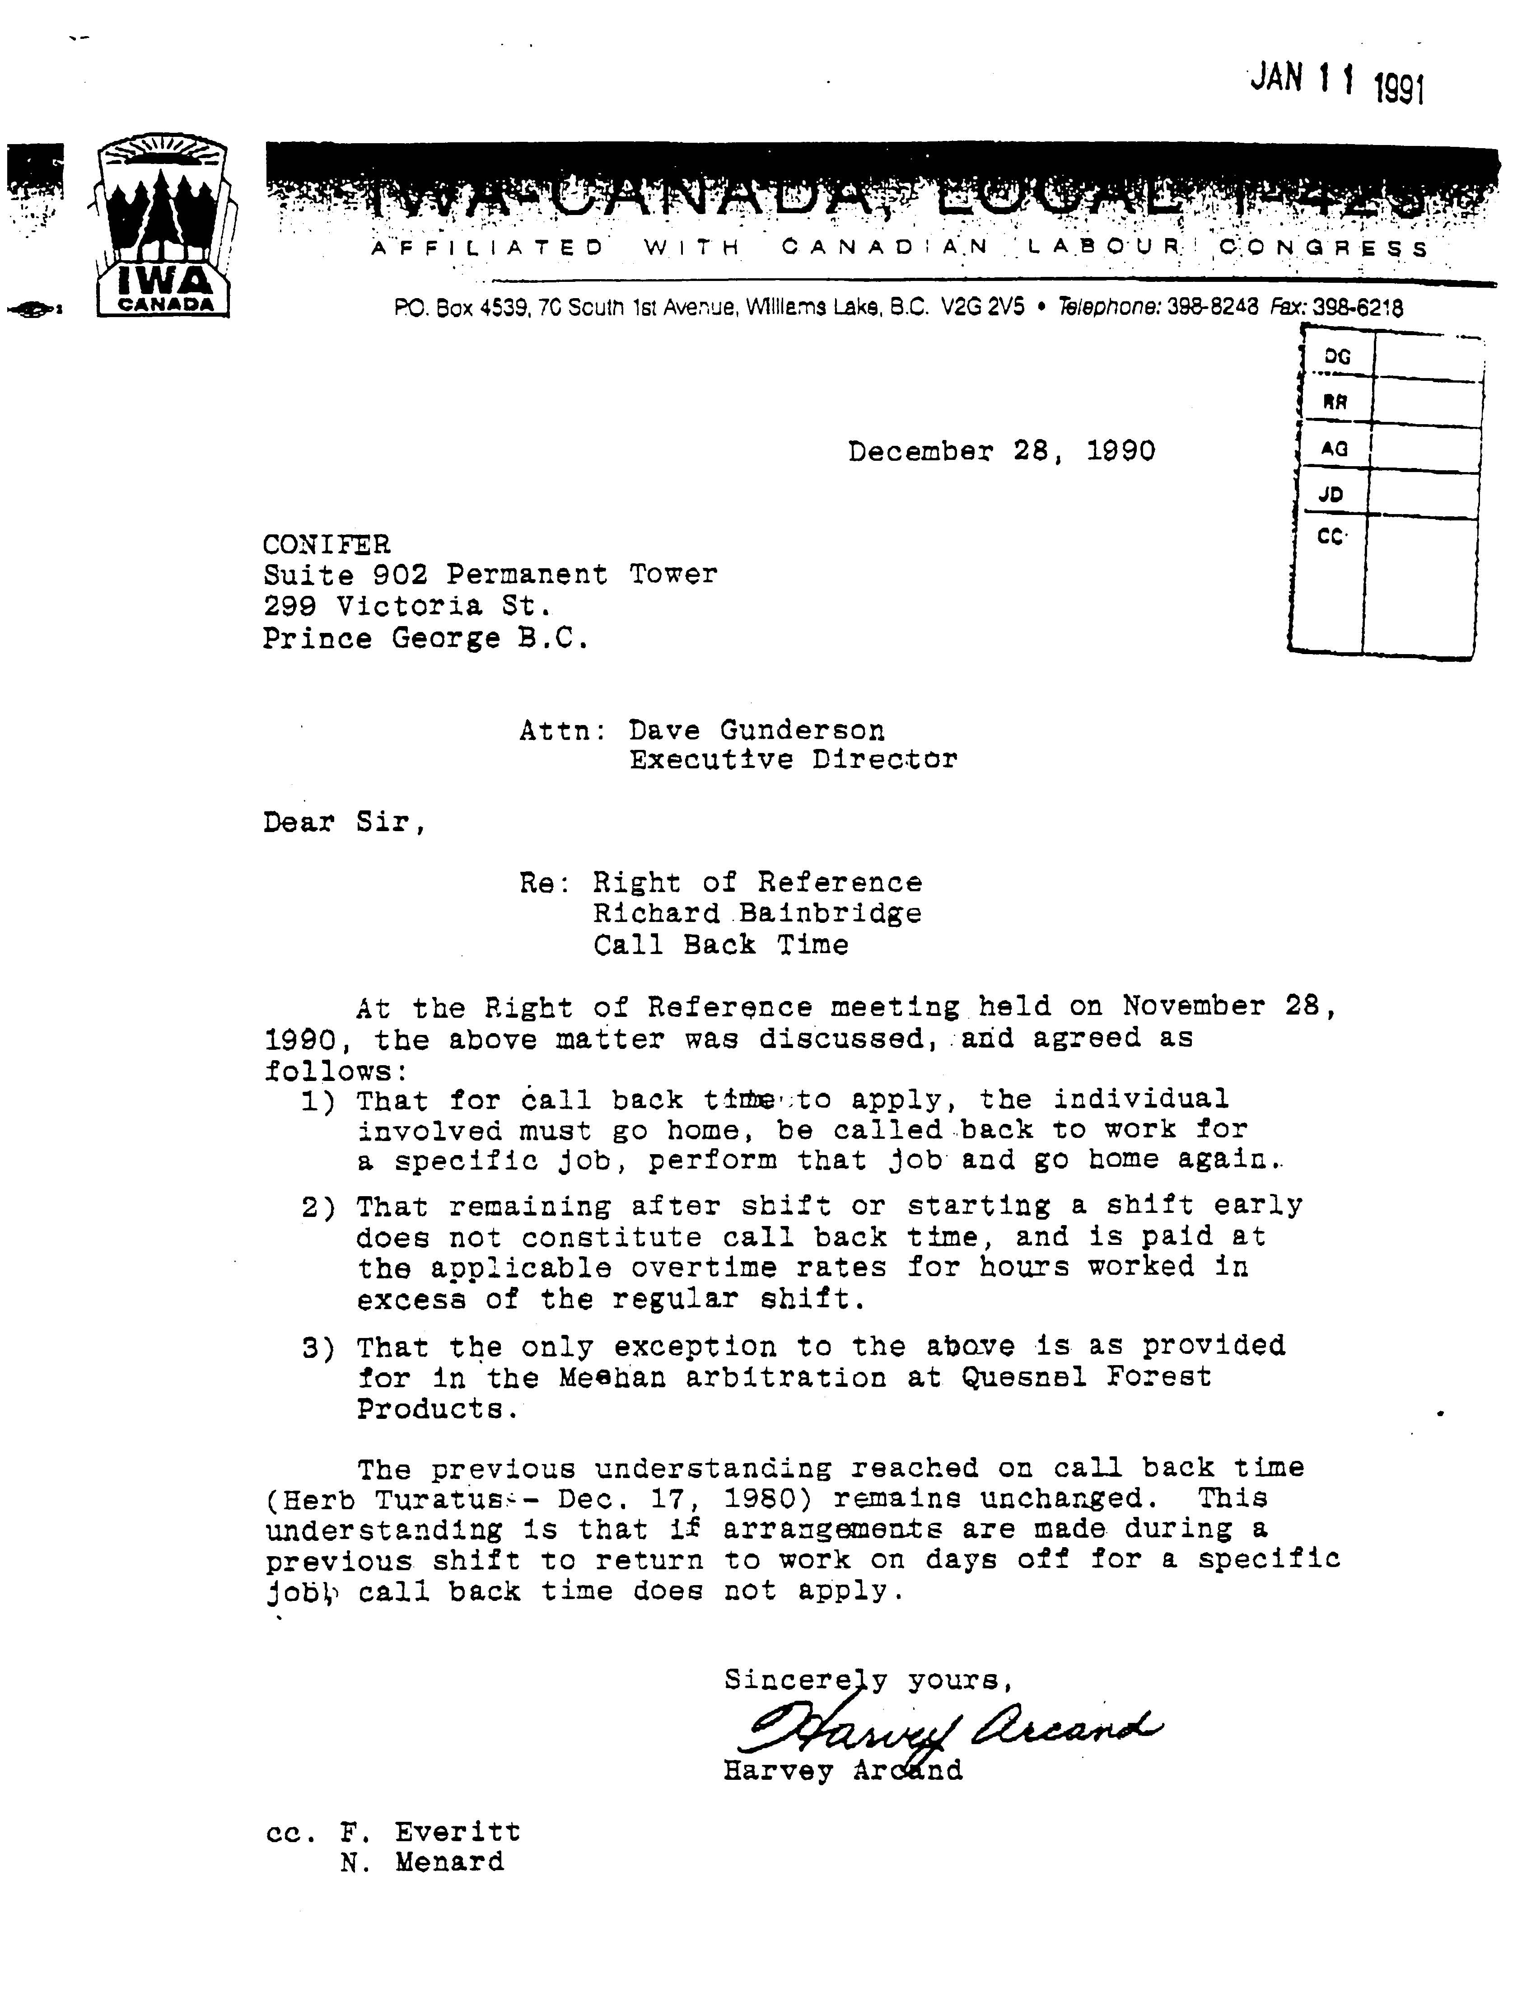
Case References– Article VII, Hours of Work and Overtime Section 10:

- Quesnel Forest Products and IWA Canada, Local 1-424
Arbitrator: Vince Ready, June 22, 1987
Click here to read this case reference

Conclusion: The grievor, an electrician, was called at home 2 hours before the start of their scheduled shift to fix a problem. They arrived at work soon thereafter, fixed the problem, remained at the work site, and commenced their regular shift. The Arbitrator ruled that Article VII (10) (now 9) was applicable.

Text:
ARTICLE VII - HOURS OF WORK AND OVERTIME

Section 10:

Employees employed in manufacturing plants will be provided two (2) ten-minute breaks, one (1) within each half of a shift, at a time designated by the Company, which shall not be later than one (1) hour before the end of each half shift.

It is agreed that the two (2) breaks in the above paragraph will be applicable to shifts of seven and one-half (7 ½) hours or more. When a shift is less than seven and one-half (7 ½) hours (i.e.: six and one-half (6 ½) hour graveyard shift) only one (1) break will be given.

Guidelines:
ARTICLE VII - HOURS OF WORK AND OVERTIME

Section 10:

Manufacturing plant employees are entitled to two ten-minute rest periods during each regular shift, provided the shift duration is 7 ½ hours or more. Only one break is provided on a short shift of less than 7 ½ hours (i.e. 6 ½ hour graveyard shift). The timing of the rest periods is at the discretion of the Company, but should occur within reason, ideally within the mid two hours of each half of a regular shift. Operational problems or breakdowns may warrant changing the break time. In any event, they are not to be taken later than 1 hour before the end of the relevant half of a shift.

The Company has the right to utilize relief employees to fill in for those away during the rest period. The ten-minute period is the length of time spent away from the work station, as opposed to time spent in a lunch room. The Company can stagger the rest periods to minimize the effect on plant operation.

In circumstances where employers fail to provide paid rest breaks for employees as required under Section 10 of Article VII, it is CONIFER’s opinion that employers are obligated to compensate employees at time and one half for the missed rest break. CONIFER’s opinion on this issue is based on a legal analysis drafted by Andrew Wood of Alexander, Holburn, Beaudin & Lang dated October 17, 2007 titled “Consequences of Employer’s Failure to Schedule Paid Rest Breaks.” Contact CONIFER for a copy of the legal opinion if required.
Text:
ARTICLE VII - HOURS OF WORK AND OVERTIME

Section 11: Casual Work

- The term ‘Casual Work’ as used in this Agreement shall apply only to work performed on Saturday and/or Sunday by either laid-off regular employees or other persons hereinafter referred to as ‘Casual Employees’.

- Casual Employees on maintenance, repair or preparatory work shall be paid straight-time rates, and those on production shall be paid rate and one-half for all work performed on Saturday and Sunday.

- Casual work on maintenance, repair and preparatory work will be paid at straight-time job rate.

- Regular laid-off employees shall not be classified as Casual Employees, and shall have preference for available work over the said casual employees.

e) The employer agrees to keep a separate seniority list of casual employees who have worked at least ten (10) working days, exclusively for recall purposes and, subject to clause d), further agrees to recall casual employees in accordance with their seniority as set forth in this list.

Guidelines:
ARTICLE VII - HOURS OF WORK AND OVERTIME

Section 11: Casual Work

This section deals with casual work performed on Saturday and/or Sunday and defines ‘casual employee’ as the category of employee performing such work. Casual work is work of a maintenance, repair, or preparatory nature and is paid at straight time. Casual employees engaged in actual production activity on Saturday/Sunday are paid at rate and one-half.

Casual employees who have accumulated ten working days, either on regular production or casual work, will be entitled to ‘Casual Seniority’ and must be recalled in accordance with their seniority as set forth on the ‘Casual Seniority’ list for all causal work. Regular laid off employees must be recalled prior to recalling casual employees. Casual employees not on the ‘Casual Seniority’ list may be called for work at management’s discretion after all casuals with seniority have been recalled.

Regular laid off employees, while they are not classified as casual employees, are entitled to preference for casual work, but are paid on the same basis as casual employees performing similar work.

It should be noted that a regular laid off employee who works a casual shift will have their seniority retention completely reinstated as of that date. (See Article VIII, Seniority)

It should be further noted that laid off regular employees or casual employees who work an entire week (i.e. as spareboard employees) are not entitled to the weekend casual work. However, if they additionally work the weekend casual work, they would be entitled to the appropriate overtime rates.

In an April 1998, Right of Reference proceeding, questions pertaining to the administration of this section were addressed by the CONIFER - IWA Negotiating Committee. See the following attached letter from Dave Gunderson to Plateau Mills regarding casual work in follow-up to the right of reference meeting.

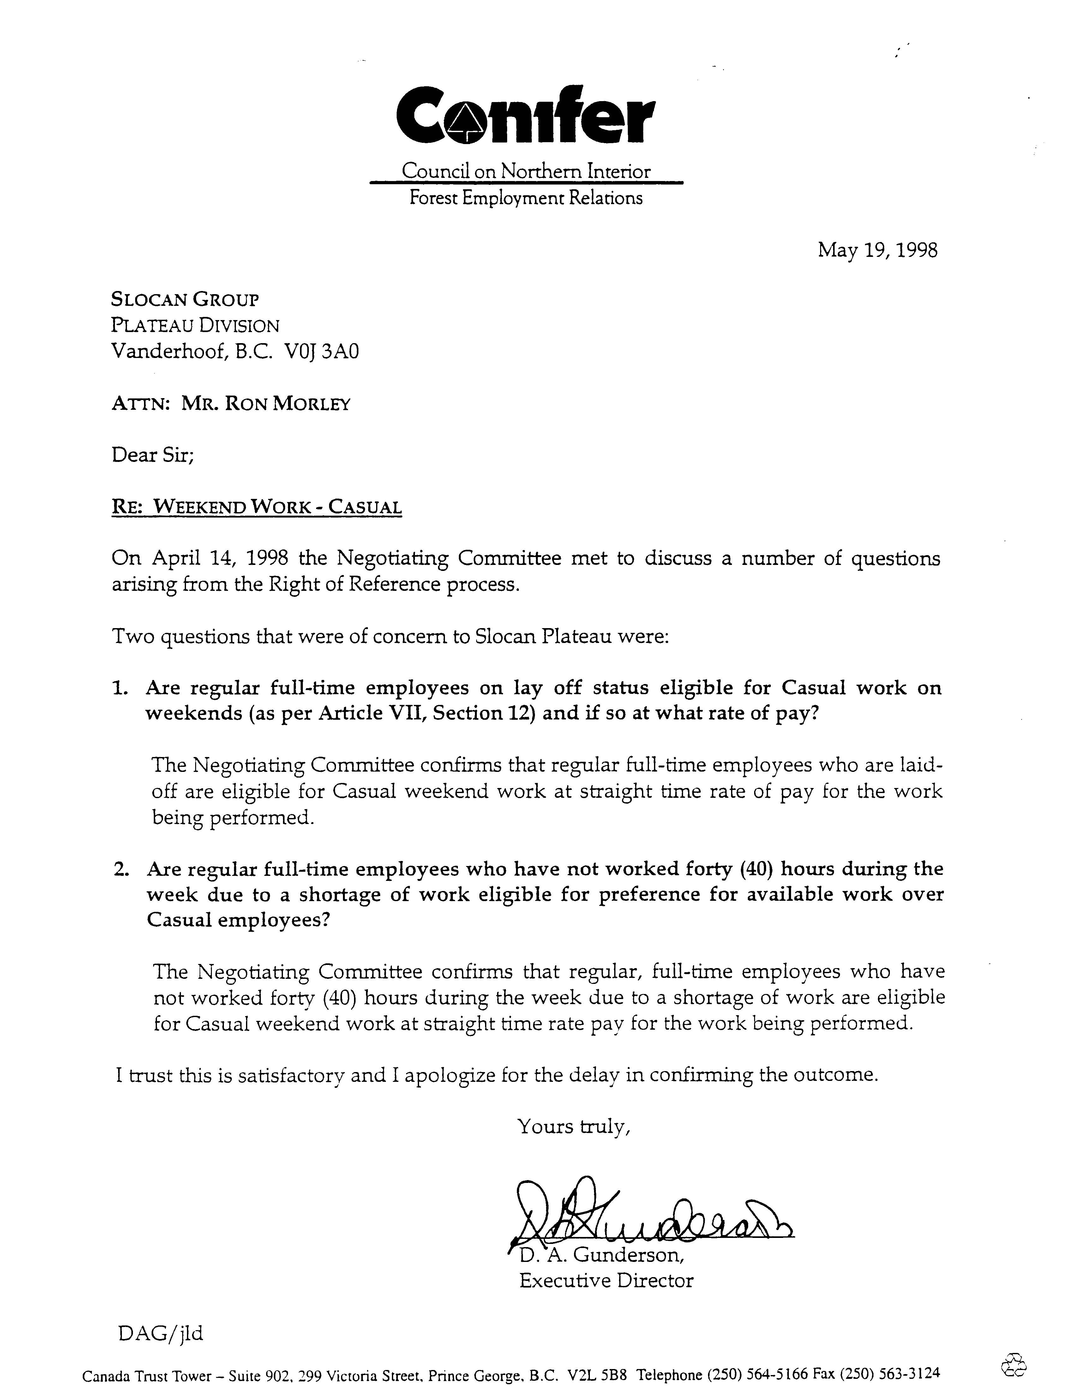
Text:
ARTICLE VII - HOURS OF WORK AND OVERTIME

Section 12:

When an employee is unavoidably prevented from reporting for their scheduled shift, if reasonably possible, they must give notice to their supervisor, or at the Company office, at least two hours before the shift commences.

Guidelines:
ARTICLE VII - HOURS OF WORK AND OVERTIME

Section 12:

It is suggested that Employers ensure there are clear avenues of communication and develop a policy in order that employees can meet the obligations of this section.

It is strongly recommended that Employers clearly communicate attendance management expectations to employees and to outline notification procedures consistent with this section.

Text:
ARTICLE VII - HOURS OF WORK AND OVERTIME

Section 13: Hot Meals

Where maintenance, repair or construction employees are required to work two (2) hours or more overtime beyond their normal shift, the Company shall provide a hot meal to be consumed by the employee on Company time before beginning the overtime work.

Guidelines:
ARTICLE VII - HOURS OF WORK AND OVERTIME

Section 13: Hot Meals

Hot meals are to be provided for maintenance, repair, or construction employees only and only where two or more hours of unexpected and/or unscheduled overtime is required beyond their normal shift. (If this overtime has been scheduled in advance the employee is expected to be prepared and there is no obligation on the company to provide a hot meal). The hot meal is to be consumed on Company time before starting the overtime work, but the eating period is not considered part of the two hours overtime above. It is recommended that pay not be substituted in lieu of a hot meal, and an understanding has been reached with the union in that regard.

There is a case in the jurisprudence from the sawmill industry regarding “hot meals”. However, it is from the coastal region, and is based on DIFFERENT collective agreement content and practice. (See Case Reference #1). Should the Union reference this case as relevant to a scenario in CONIFER member operations; we clarify here that it is NOT.

Case References– Article VII, Hours of Work and Overtime Section 14: Hot Meals

1. Interfor Corporation (Acorn Division) and USW Local 2009
Arbitrator; July Nichols, February 11, 2020.
Click here to read this case reference

Conclusion: “……the language of the Collective Agreement and the evidence supports the conclusion that hot meal entitlements apply to the maintenance employees (or their relief) who accept and work 10 hours on Saturday as part of the scheduled maintenance shift.”

NOTE - CONIFER POSITION IS THIS CASE IS NOT APPLICABLE UNDER CONIFER COLLECTIVE AGREEMENT LANGUAGE AND HISTORICAL PRACTICE.

